WIDE AREA NETWORK: Expands over a large area of the world.

[](http://www.google.com/url?sa=i&rct=j&q=computer&source=images&cd=&cad=rja&uact=8&docid=D2JGf4ceZBirGM&tbnid=H9EE4Lh4JHiGMM:&ved=0CAUQjRw&url=https://play.google.com/store/apps/details?id=com.pcvirt.Computer&ei=BQhhU9SfMcnc2gXAooDgBQ&bvm=bv.65636070,d.b2U&psig=AFQjCNH4Ij156x041MEK-skkPDNP-WvxiA&ust=1398954352351740)[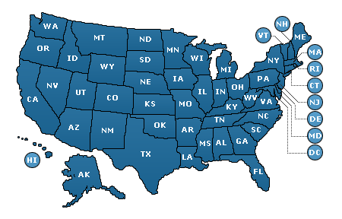](http://www.google.com/url?sa=i&rct=j&q=united+states&source=images&cd=&cad=rja&uact=8&docid=UUhmpsp9eb2FLM&tbnid=DgPkUXzg2vpNSM:&ved=0CAUQjRw&url=http://www.angieslist.com/companylist/us/&ei=rgdhU_v6NIn38AHYqICYBA&bvm=bv.65636070,d.b2U&psig=AFQjCNEhuTYImQCtAVXu6onVJGS6KNLbMw&ust=1398954266839936)

LOCAL AREA NETWORK:

[](http://www.google.com/url?sa=i&rct=j&q=computer&source=images&cd=&cad=rja&uact=8&docid=D2JGf4ceZBirGM&tbnid=H9EE4Lh4JHiGMM:&ved=0CAUQjRw&url=https://play.google.com/store/apps/details?id=com.pcvirt.Computer&ei=BQhhU9SfMcnc2gXAooDgBQ&bvm=bv.65636070,d.b2U&psig=AFQjCNH4Ij156x041MEK-skkPDNP-WvxiA&ust=1398954352351740)[](http://www.google.com/url?sa=i&rct=j&q=computer&source=images&cd=&cad=rja&uact=8&docid=D2JGf4ceZBirGM&tbnid=H9EE4Lh4JHiGMM:&ved=0CAUQjRw&url=https://play.google.com/store/apps/details?id=com.pcvirt.Computer&ei=BQhhU9SfMcnc2gXAooDgBQ&bvm=bv.65636070,d.b2U&psig=AFQjCNH4Ij156x041MEK-skkPDNP-WvxiA&ust=1398954352351740)