Your path to victory!
Champ Paddle
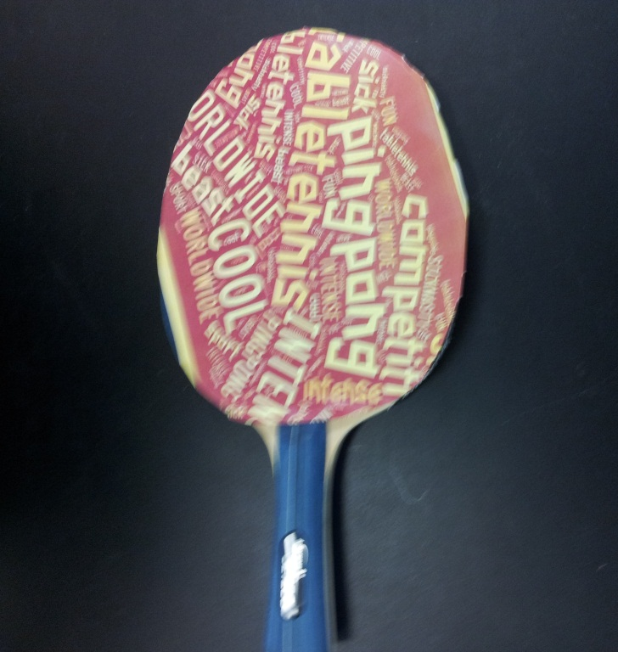
ANY COLOR, ANY SIZE, ANY CHAMPION
This could be yours now for only $20.00!!!
This product is not available in stores.
This here is a ping pong paddle for all levels. It will help you become a champion! It can be customized to say anything you want and ships in under a week.

Ping Pong Paddle

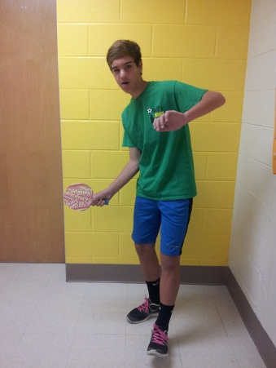
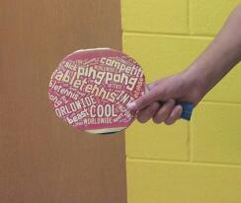
You Can Be A Champion

If you call in the next 24 hours, it will be 50% off!
This offer is not available in stores.
So call now and become a one-of-a-kind champion with an unstoppable paddle.
Call 444-444-4444 or
Go to www.champaddles.com

